R-assignment 1 Bio 1002
Mackenzie Parsons
Student ID: 202511568

Question 1: library(dplyr)

Question 2: moosedata <- read.csv("MoosePopulation.csv")

Question 3: moose_clean <- na.omit(moosedata)

Question 4: moose_sel <- select(moose_clean, Ecoregion, Year, Area, Estimated_Moose_Pop)

Question 5:
# oldest observation code: year_min <- min(moose_sel$Year, na.rm = TRUE)
Answer a: 1904

# Highest estimated moose population code: moose_max <- max(moose_sel$Estimated_Moose_Pop, na.rm = TRUE)
Answer b: 41,250

Question 6: code: moosedata2 <- mutate(moose_sel, MooseDensity = Estimated_Moose_Pop / Area)
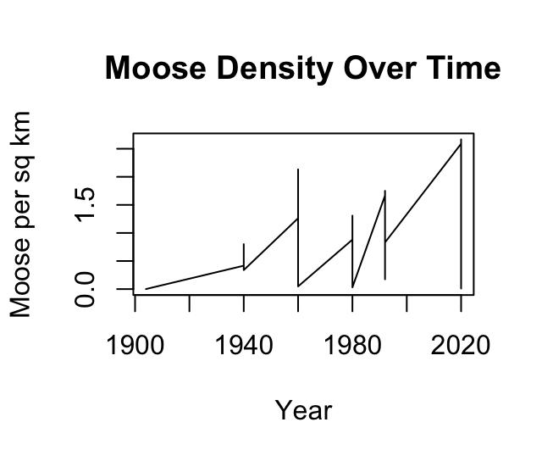

Question 8:
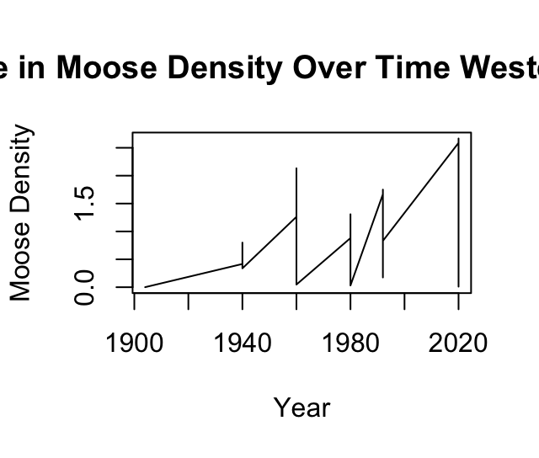

Question 9:
a.) moose_2020 <- filter(moosedata2, Year == 2020)
b.)moose_2020_high <- filter(moose_2020, MooseDensity > 2.0)
c.) moose_2020_high_byD <- arrange(moose_2020_high, desc(MooseDensity))

Question 10:
Ecoregion Year Area
1 Northern_Peninsula_Forests 2020 12000
2 North_Shore_Forests 2020 8400
3 Western_Forests 2020 6800
4 Central_Forests 2020 20500
Estimated_Moose_Pop MooseDensity
1 32000 2.666667
2 21740 2.588095
3 17000 2.500000
4 41250 2.012195

Part ||: Tree Sapling Study

12.) a.) Ecoregion AverageBrowsing
<chr> <dbl>
1 Avalon_Forests 2
2 Central_Forests 4
3 EasternHyperOceanicBarrens 2.4
4 Long_Range_Barrens 2.6
5 Maritime_Barrens 1.83
6 North_Shore_Forests 4.38
7 Northern_Peninsula_Forests 4.57
8 StraitOfBelleIsleBarrens 1
9 Western_Forests 4.5

b.) # Highest browsing: Western_Forests- 4.57
#Lowest browsing: StraitOfBelleIsleBarrens- 1

Question 13.)
a.) Ecoregion AverageHeight
<chr> <dbl>
1 Avalon_Forests 32.4
2 Central_Forests 23.8
3 EasternHyperOceanicBarrens 31.6
4 Long_Range_Barrens 29.9
5 Maritime_Barrens 26.7
6 North_Shore_Forests 22.3
7 Northern_Peninsula_Forests 19.9
8 StraitOfBelleIsleBarrens 25.4
9 Western_Forests 18.9

b.) Ecoregion AverageHeight
<chr> <dbl>
1 Northern_Peninsula_Forests 19.9
2 Western_Forests 18.9

Question 14.)
a.) Species AverageBrowsing
<chr> <dbl>
1 "Alder " 4.25
2 "Balsam_Fir" 3.14
3 "Black_Ash" 5
4 "Black_Spruce" 2.33
5 "White_Birch" 3.14
6 "Willow" 4.31

b.)
Species AverageBrowsing
<chr> <dbl>
1 "Black_Ash" 5
2 "Willow" 4.31
3 "Alder " 4.25
4 "White_Birch" 3.14
5 "Balsam_Fir" 3.14
6 "Black_Spruce" 2.33
Highest : Black_ash
Lowest: Black spruce

Question 15:
Ecoregion AverageBrowsing
<chr> <dbl>
1 North_Shore_Forests 4.5
2 Northern_Peninsula_Forests 4.25
3 Central_Forests 3.5
4 Avalon_Forests 2
5 EasternHyperOceanicBarrens 2
6 Maritime_Barrens 2
7 Long_Range_Barrens 1

Highest: North_shore_forests - 4.5
Lowest: Long_range_barrens - 1

Question 16:
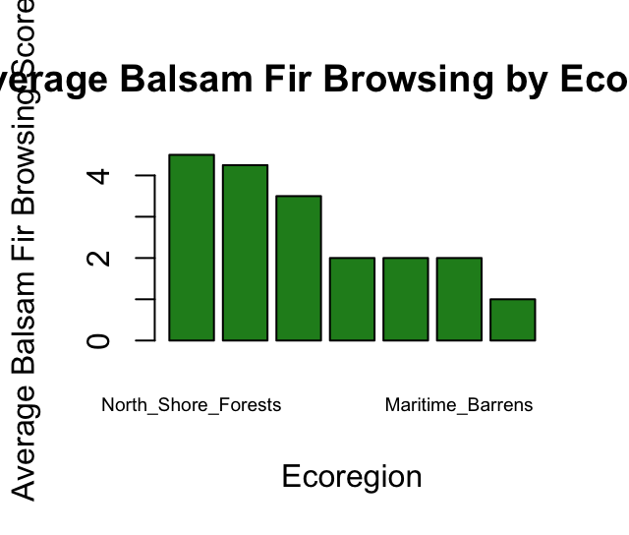

Question 17.)
a.) Ecoregion AverageBrowsing
<chr> <dbl>
1 North_Shore_Forests 4
2 Northern_Peninsula_Forests 4
3 Western_Forests 3.5
4 Central_Forests 3
5 Long_Range_Barrens 2
6 Avalon_Forests 0.5
7 EasternHyperOceanicBarrens 0
8 Maritime_Barrens 0

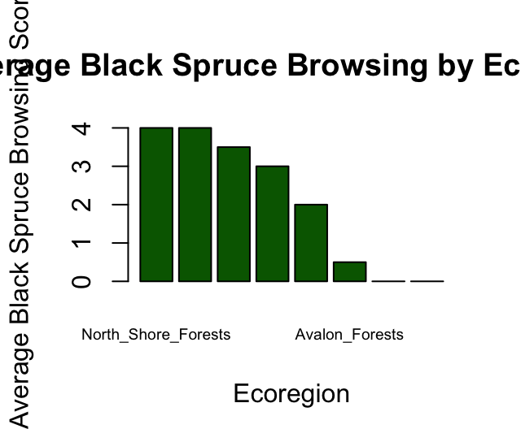
b.)

c.)
# Black Spruce generally experiences lower browsing intensity than Balsam Fir across most ecoregions.
#The highest browsing for Black Spruce occurs in North_Shore_Forests, similar to Balsam Fir, but the overall averages are lower.

Question 18:
Ecoregion n
<chr> <int>
1 Avalon_Forests 5
2 Central_Forests 5
3 EasternHyperOceanicBarrens 5
4 Long_Range_Barrens 5
5 Maritime_Barrens 3
6 North_Shore_Forests 8
7 Northern_Peninsula_Forests 7
8 StraitOfBelleIsleBarrens 1
9 Western_Forests 5

Question 19:
Species n
<chr> <int>
1 "Alder " 8
2 "Balsam_Fir" 11
3 "Black_Ash" 1
4 "Black_Spruce" 9
5 "White_Birch" 7
6 "Willow" 8
#No, the same number of tree saplings were not counted for each species.

Question 20:
# The SaplingStudy dataset is not evenly distributed
#Balsam_Fir and some forest regions are overrepresented,while Black_Ash and some barrens are underrepresented.

Part |||: Creating and Joining Datasets

Question 22:
Species Ecoregion AvgBrowsing
<chr> <chr> <dbl>
1 "Alder " Avalon_Forests 4
2 "Alder " Central_Forests 4.5
3 "Alder " EasternHyperOcean… 4
4 "Alder " Long_Range_Barrens 3.5
5 "Alder " Maritime_Barrens 3.5
6 "Alder " North_Shore_Fores… 4.5
7 "Alder " Northern_Peninsul… 5
8 "Alder " Western_Forests 5
9 "Balsam_Fir" Avalon_Forests 2
10 "Balsam_Fir" Central_Forests 3.5

Question 23:
a.) # The figure below shows that at low moose densities, certain species like the Balsam Fir have higher browsing scores. Indicating that moose show strong preferences. At higher densities, browsing spreads across more species, suggesting generalist behaviour.
b.) #Moose favor Balsam fir and black spruce the most, as these have the highest browsing scores. They browse species like Black Ash or White birch the least, which have lower scores.
c.) #Black ash is likely not shown because it was very underrepresented in the dataset (only 1 tree) so there isn't enough data to calculate an average browsing score.

Question 25:
Ecoregion Year Area
1 North_Shore_Forests 2020 8400
2 Northern_Peninsula_Forests 2020 12000
3 Long_Range_Barrens 2020 8800
4 Central_Forests 2020 20500
5 Western_Forests 2020 6800
6 EasternHyperOceanicBarrens 2020 4400
Estimated_Moose_Pop MooseDensity
1 21740 2.5880952
2 32000 2.6666667
3 5300 0.6022727
4 41250 2.0121951
5 17000 2.5000000
6 2200 0.5000000
collisions2020 human_pop
1 56 18000
2 60 12000
3 14 4000
4 36 75100
5 48 24000
6 10 3500

Question 26:
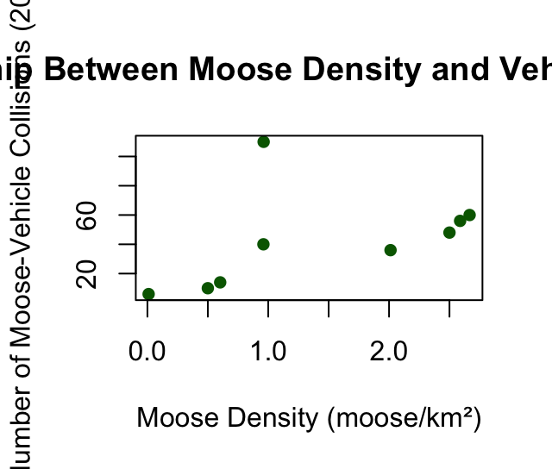

b.) #Generally, higher moose density corresponds to more moose-vehicle collisions, indicating a positive relationship. There may be some outliers, e.g Avalon forests have very high collisions despite moderate density.

Questions 27.)
Ecoregion Year Area
1 North_Shore_Forests 2020 8400
2 Northern_Peninsula_Forests 2020 12000
3 Long_Range_Barrens 2020 8800
4 Central_Forests 2020 20500
5 Western_Forests 2020 6800
6 EasternHyperOceanicBarrens 2020 4400
7 Maritime_Barrens 2020 21300
8 Avalon_Forests 2020 4200
9 StraitOfBelleIsleBarrens 2020 500
Estimated_Moose_Pop MooseDensity
1 21740 2.5880952
2 32000 2.6666667
3 5300 0.6022727
4 41250 2.0121951
5 17000 2.5000000
6 2200 0.5000000
7 20450 0.9600939
8 4040 0.9619048
9 5 0.0100000
collisions2020 human_pop coll_per_capita
1 56 18000 0.0031111111
2 60 12000 0.0050000000
3 14 4000 0.0035000000
4 36 75100 0.0004793609
5 48 24000 0.0020000000
6 10 3500 0.0028571429
7 40 32000 0.0012500000
8 110 270000 0.0004074074
9 6 2300 0.0026086957

Question 28.)
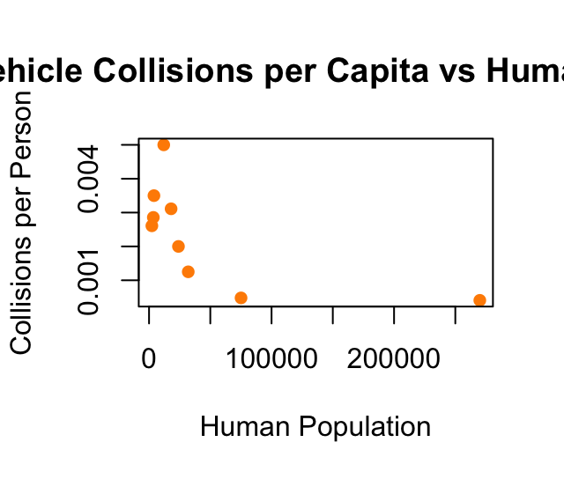

Question 29.) # Generally, ecoregions with smaller human populations tend to have higher collisions per person,even if the total number of collisions is moderate . This makes sense because in sparsely populated areas, each collision represents a larger proportion of the population, and moose are more likely to roam near roads in less developed regions.

